Annex C

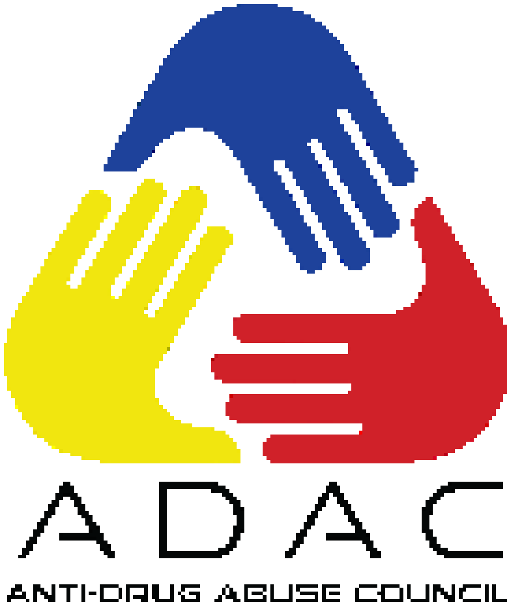

Republic of the Philippines
DEPARTMENT OF THE INTERIOR AND LOCAL GOVERNMENT
DILG-NAPOLCOM Center, EDSA corner Quezon Avenue, Quezon City
www.dilg.gov.ph

DILG PHILIPPINE ANTI-ILLEGAL DRUGS STRATEGY -
PROJECT MANAGEMENT OFFICE

anti-drug abuse council
performance audit
DOCUMENT CHECKLIST

_____ ANTI-DRUG ABUSE COUNCIL (ADAC) PERFORMANCE AUDIT: DOCUMENT CHECKLIST FOR CITY AND MUNICIPAL ADACs
DC 1

City / Municipality |  |  | Region
Province |  |  | Date Accomplished
Instructions:
- Data to be used for CY _____ audit is CY _____data.
- Kindly put a check (✓) under column 2 if the required document is available for submission while put a cross (x) if the document is unavailable.
- In case of correction/s, affix signature beside the corrected item/s.
- C/MADAC Chairperson must affix a signature at the bottom of every page of this document.
- Certified True Copies of the required documents must be attached to the checklist before submission to C/MLGOO and/or City Director.
- Document checklist and all its attachment must be submitted to C/MLGOO and/or City Director on or before May 21, 2021.
REQUIRED DOCUMENTS  (1) |  |  | PRESENCE/  ABSENCE  (2) | CONDITIONAL DOCUMENT/REMARKS  (3)
Indicator 1 – Organized Local ADAC – Organized Local ADAC
1 | Executive Order or Local Ordinance containing the creation or reorganization of the Anti-Drug Abuse Council |  |  | Certification from concerned NGA stating that mandatory ADAC Member is Vacant/Not Applicable in City/Municipality
Indicator 2 – Allocation of substantial amount as indicated in the ADAC Plan
1 | _____ Approved POPS Plan
2 | _____ Annual Budget
3 | _____ Annual Investment Plan
4 | _____ Certification from the Budget Officer re: Allocation of funds for the implementation of Anti-Illegal Drug Activities or for the activities in the POPS Plan
I declare under oath that all the information contained herein are true, correct and complete pursuant to the provisions of pertinent laws, rules, and regulations of the Republic of the Philippines. I authorize the agency head or his duly authorized representative to verify and validate the contents stated herein. I agree that any misrepresentation made in this document and all its attachments shall be grounds for the filing of appropriate administrative and/or criminal case/s against me.

C/MADAC Chairperson Signature over printed name

_____ ANTI-DRUG ABUSE COUNCIL (ADAC) PERFORMANCE AUDIT: DOCUMENT CHECKLIST FOR CITY AND MUNICIPAL ADACs
DC 1

Indicator 3 – Implementation of Plans and Programs
1 | Certification from Accountant re: Fund utilization on Anti-Illegal Drug campaign
2 | ADAC Annual Accomplishment Report signed by Mayor
3 | Certification from PDEA/Regional Oversight Committee (ROC) stating the following:  - Number of Drug-Affected Barangays within the City/Municipality as of end of _____  - Number of Drug-Cleared Barangays within City/Municipality as of end of _____  Or if applicable, Certification from PDEA that City/Municipality has achieved/maintained Drug-free status in _____
4 | Activity Design of all implemented Anti-Illegal Drug Activities for all quarters
5 | Post-Activity Reports for all implemented Anti-illegal Drug Activities for all Quarters
Indicator 4 – Support to ADACs in Component LGUs
1 | CSAR plan or CBDRP plan
2 | Executive Order OR Certification from the accountant regarding the financial support given to the component BADACs
3 | Executive Order OR Terminal Report regarding the technical support given to the component BADACs |  |  |  | Certificate of Recognition from Component ADACs in relation to support/provided for Anti-Illegal Drug Activities
I declare under oath that all the information contained herein are true, correct and complete pursuant to the provisions of pertinent laws, rules, and regulations of the Republic of the Philippines. I authorize the agency head or his duly authorized representative to verify and validate the contents stated herein. I agree that any misrepresentation made in this document and all its attachments shall be grounds for the filing of appropriate administrative and/or criminal case/s against me.

C/MADAC Chairperson Signature over printed name

I declare under oath that all the information contained herein are true, correct and complete pursuant to the provisions of pertinent laws, rules, and regulations of the Republic of the Philippines. I authorize the agency head or his duly authorized representative to verify and validate the contents stated herein. I agree that any misrepresentation made in this document and all its attachments shall be grounds for the filing of appropriate administrative and/or criminal case/s against me.

C/MADAC Chairperson Signature over printed name

____ ANTI-DRUG ABUSE COUNCIL (ADACs) PERFORMANCE AUDIT:
DOCUMENT CHECKLIST FOR CITY AND MUNICIPAL ADACs
DC 1

Indicator 5 – Conduct of quarterly meetings
1 | Notice for Quarterly meetings
2 | Minutes of Quarterly meetings conducted
Indicator 6 – Innovations
1 | For LGU – Initiated Activities/Facility/Program  - Interviews  - Articles  - Report on initiative
2 | For ADAC Member Agency – Initiated Activity/Facility/Program  - ADAC Member Agency report on initiative  - ADAC Resolution endorsing ADAC member agency initiative
3 | For CSO – Initiated Activity/Facility/Program  - CSO Report on initiative  - ADAC Resolution endorsing CSO initiative

No. of documents present: ______________
No. of documents unavailable: __________

I declare under oath that all the information contained herein are true, correct and complete pursuant to the provisions of pertinent laws, rules, and regulations of the Republic of the Philippines. I authorize the agency head or his duly authorized representative to verify and validate the contents stated herein. I agree that any misrepresentation made in this document and all its attachments shall be grounds for the filing of appropriate administrative and/or criminal case/s against me.

C/MADAC Chairperson Signature over printed name

_____ ANTI-DRUG ABUSE COUNCIL (ADAC) PERFORMANCE AUDIT: DOCUMENT CHECKLIST FOR PROVINCIAL ADACs
DC 2

I declare under oath that all the information contained herein are true, correct and complete pursuant to the provisions of pertinent laws, rules, and regulations of the Republic of the Philippines. I authorize the agency head or his duly authorized representative to verify and validate the contents stated herein. I agree that any misrepresentation made in this document and all its attachments shall be grounds for the filing of appropriate administrative and/or criminal case/s against me.

PADAC Chairperson Signature over printed name

Province |  |  | Region
 |  |  | Date Accomplished
Instructions:
- Data to be used for CY _____ audit is CY _____ data
- Kindly put a check (✓) under column 2 if the required document is available for submission while put a cross (x) if the document is unavailable.
- In case of correction/s, affix signature beside the corrected item/s.
- PADAC Chairperson must affix a signature at the bottom of every page.
- Certified True Copies of the required documents must be attached to the checklist before submission to the Provincial Director.
- Document checklist and all its attachment must be submitted to Provincial Director on or before June 25, 2021
REQUIRED DOCUMENTS  (1) |  |  | PRESENCE/  ABSENCE  (2) | CONDITIONAL DOCUMENT/REMARKS  (3)
Indicator 1 – Creation / Reorganization of ADAC
1 | Executive Order or Local Ordinance containing the creation or reorganization of the Anti-Drug Abuse Council |  |  | Certification from concerned NGA stating that mandatory ADAC Member is Vacant/Not Applicable in City/Municipality
Indicator 2 – Allocation of substantial amount as indicated in the ADAC Plan
1 | Approved POPS Plan
2 | Local Annual Budget
3 | Local Annual Investment Plan
4 | _____ Certification from the Budget Officer re: Allocation of funds for the implementation of Anti-Drug Activities or for the activities in the POPS Plan
Indicator 3 – Implementation of Plans and Programs
1 | Certification from Accountant re: Fund utilization on Anti-Illegal Drug campaign
2 | ADAC Annual Accomplishment Report signed by Governor
3 | Certification from PDEA/Regional Oversight Committee (ROC) stating the following:  - Number of Drug-Affected Barangays within the City/Municipality as of end of _____  - Number of Drug-Cleared Barangays within City/Municipality as of end of _____  Or if applicable, Certification from PDEA that City/Municipality has achieved/maintained Drug-free status in _____
4 | Documentation of SDEC Facilities/Program or any equivalent documents
5 | Activity Design / Project Proposal of all implemented Anti-Drug Activities for all quarters
6 | Post-Activity Reports / Accomplishment Reports for all implemented Anti-Drug Activities for all Quarters
Indicator 4 – Support to ADACs in component LGUs
1 | Summary of Performance Audit Results Endorsed by APT
2 | Executive Order OR Certification from the accountant regarding the financial support given to the component C/MADACS
3 | Executive Order OR Terminal Report regarding the technical support given to the component C/MADACS |  |  | Certificate of Recognition from Component C/MADACs in relation to support/provided for Anti-Illegal Drug Activities
Indicator 5 – Conduct of quarterly meetings
1 |  | Notice for Quarterly meetings
2 |  | Minutes of Quarterly meetings conducted
_____ ANTI-DRUG ABUSE COUNCIL (ADAC) PERFORMANCE AUDIT: DOCUMENT CHECKLIST FOR PROVINCIAL ADACs
DC 2

I declare under oath that all the information contained herein are true, correct and complete pursuant to the provisions of pertinent laws, rules, and regulations of the Republic of the Philippines. I authorize the agency head or his duly authorized representative to verify and validate the contents stated herein. I agree that any misrepresentation made in this document and all its attachments shall be grounds for the filing of appropriate administrative and/or criminal case/s against me.

PADAC Chairperson Signature over printed name

_____ ANTI-DRUG ABUSE COUNCIL (ADAC) PERFORMANCE AUDIT: DOCUMENT CHECKLIST FOR PROVINCIAL ADACs
DC 2

Indicator 6 – Innovations
1 | For LGU – Initiated Activities/Facility/Program  - Interviews  - Articles  - Report on initiative
2 | For ADAC Member Agency – Initiated Activity/Facility/Program  - ADAC Member Agency report on initiative  - ADAC Resolution endorsing ADAC member agency initiative
3 | For CSO – Initiated Activity/Facility/Program  - CSO Report on initiative  ADAC Resolution endorsing CSO initiative
I declare under oath that all the information contained herein are true, correct and complete pursuant to the provisions of pertinent laws, rules, and regulations of the Republic of the Philippines. I authorize the agency head or his duly authorized representative to verify and validate the contents stated herein. I agree that any misrepresentation made in this document and all its attachments shall be grounds for the filing of appropriate administrative and/or criminal case/s against me.

PADAC Chairperson Signature over printed name

No. of documents present: ______________
No. of documents unavailable: ___________

I declare under oath that all the information contained herein are true, correct and complete pursuant to the provisions of pertinent laws, rules, and regulations of the Republic of the Philippines. I authorize the agency head or his duly authorized representative to verify and validate the contents stated herein. I agree that any misrepresentation made in this document and all its attachments shall be grounds for the filing of appropriate administrative and/or criminal case/s against me.

PADAC Chairperson Signature over printed name

